PortSwigger Web Security Academy — Proof of Concept

File Upload Lab 1

Remote code execution via web shell upload
Category | File Upload
Lab | Lab 1
Completed By | Security Researcher
Platform | PortSwigger Web Security Academy

Lab Objective
Upload a PHP web shell to the server and retrieve the contents of /home/carlos/secret.

Step-by-Step Exploitation
- Open Burp Suite and configure browser proxy.
- Navigate to the lab URL and identify the vulnerable functionality.
- Intercept the relevant HTTP request in Burp Proxy.
- Send the request to Burp Repeater for analysis.
- Craft and inject the appropriate payload into the vulnerable parameter.
- Forward the modified request and observe the response.
- Verify the exploit was successful as shown in the screenshots below.

Screenshots & Evidence
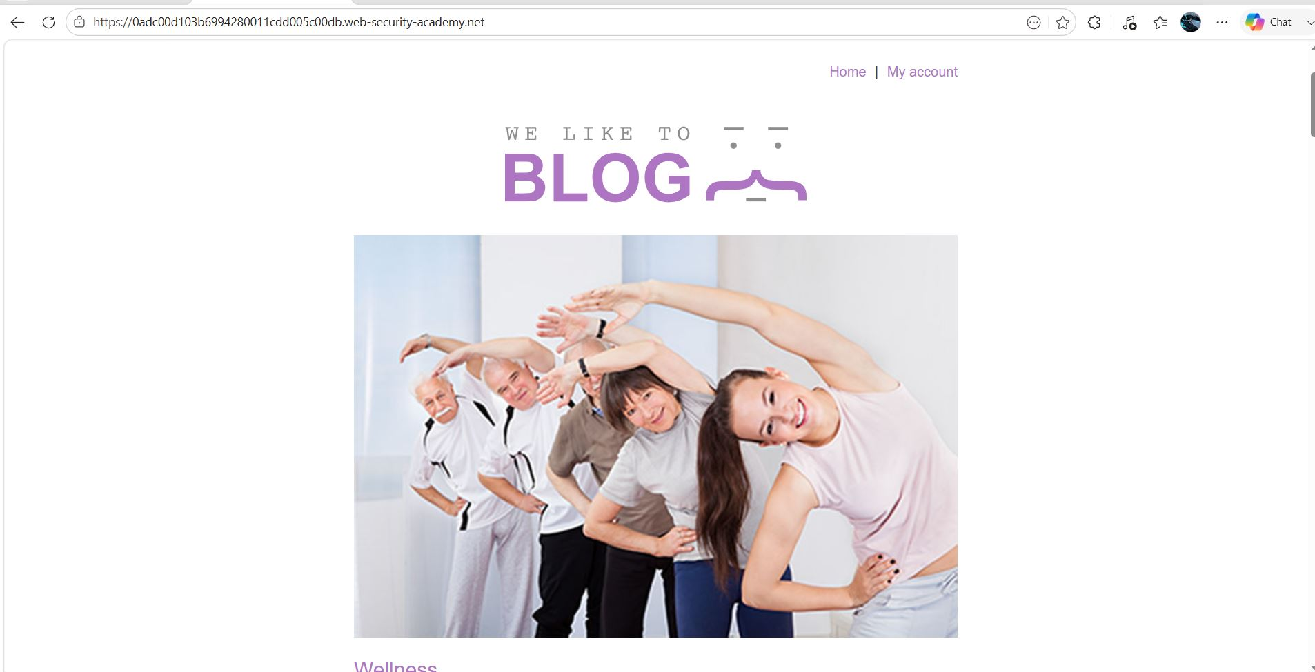
Figure 1: 1st Image
Lab Solved — Confirmation
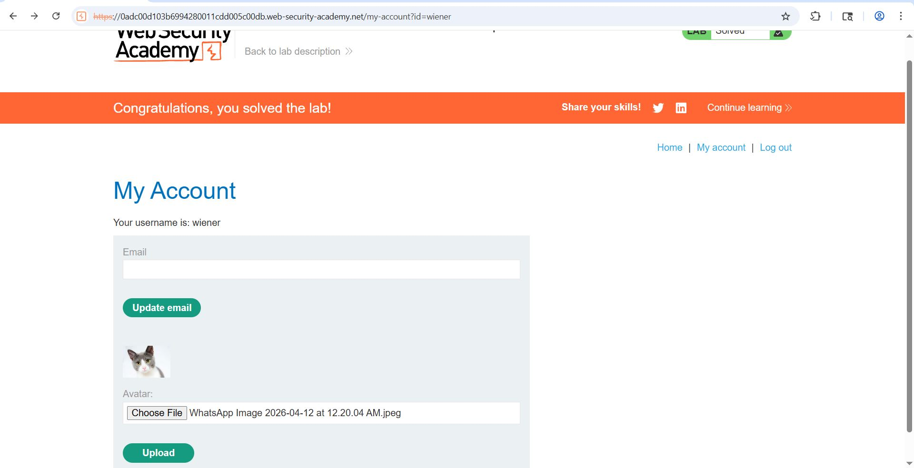
Figure 2: Final Pic
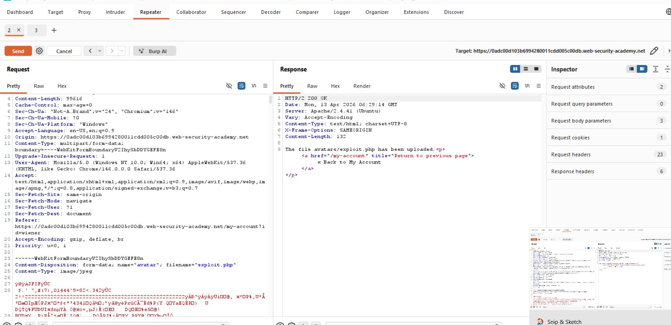
Figure 3: Repert
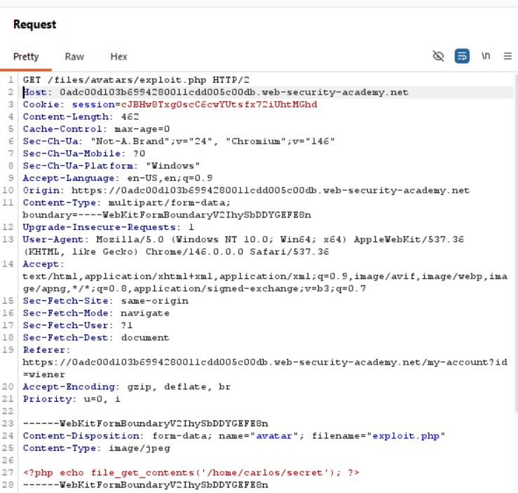
Figure 4: Request Changes
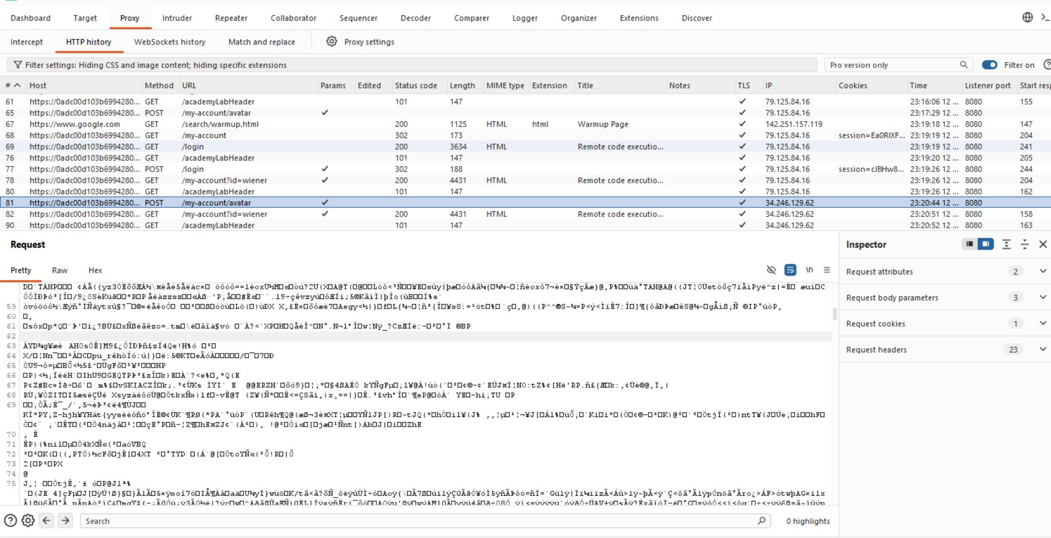
Figure 5: Request Find

Lab Status: SOLVED

